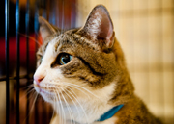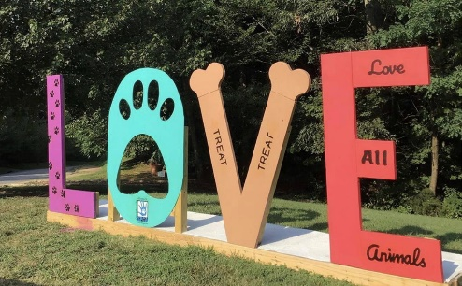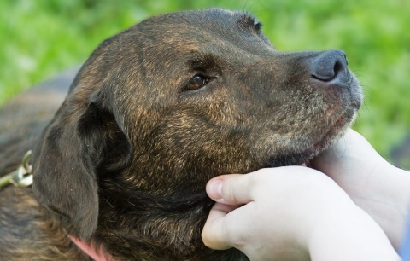

VADA members and friends! In conjunction with our 2022 Spring Sections Seminar at the Boar’s Head Resort May 4-6, VADA is collecting donations of needed funds and supplies for the Charlottesville Albemarle SPCA! Located at 3355 Berkmar Drive in Charlottesville, the CASPCA is a nonprofit animal welfare organization dedicated to providing a safe environment for the lost, abandoned, and homeless animals of Charlottesville and Albemarle County and placing them in good homes. CASPCA’s staff and volunteers strive to set a standard of excellence and leadership in animal care, humane education, and progressive animal welfare programs. VADA is proud to partner with CASPCA to help fulfill its mission and to say thank you to the Charlottesville / Albermarle County community for hosting us for our Spring meeting! To learn more about CASPCA and the great work they do, visit: <https://caspca.org/>. For a wish list of items the CSPCA can use, visit: <https://caspca.org/give/wish-list/>. Please being your donations with you to the Spring meeting. We thank you for your support!

 